**Crowdfunding Report**

1. **Given the provided data, what are three conclusions we can draw about crowdfunding campaigns?**
2. Theatre is the most preferred category leading to the crowdfunding campaign's peak. It contains the highest number of successful and failed crowdfunding campaigns. If Theatre is removed, film and video will have the highest number of successful campaigns.

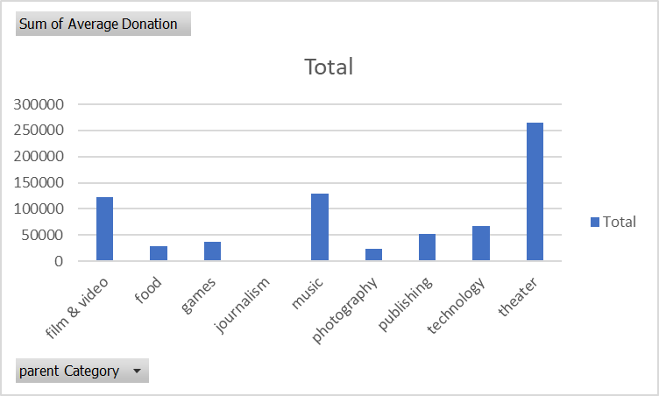

Theatre has the highest average donation; music comes seconds, and film & video third.

1. The player category has the greatest number of campaigns, with the number of successful and failed ones comparatively higher than the rest of the categories presented.

Rock comes second after Pays having the higher number of successful campaigns.

1. July has the highest number of successful campaigns and the lowest number of canceled campaigns. Across the years, successful campaigns are higher than failed and canceled combined.

July contributes largely to the overall count of the number of successful campaigns.

1. **What are some of the limitations of this dataset?**

The sample presented does not fully represent the entire population of crowdfunding projects. The projects mentioned that about 30% of the companies succeeded through funding, having positive outcomes. However, more than 50% of the selected programs were successful in the databases. The sample shows that Theatre has a few campaigns though in the overall databases, the Theatre is shown to be the most common category.

Additionally, there was no statistical metric measuring or presenting the success of each industry or category, or subcategory as a whole during the covered period. Therefore, it is important to show whether or not each category, industry, or subcategory has performed well or poorly in recent times. It would be important to account for external factors through data analysis.

There were many outliers in the funding goals or the target amount for different categories and subcategories. Blurbs for each crowdfunding campaign exist, and it would be important to have more detailed information about what each crowdfunding hopes or wishes to accomplish about actionable items. It may not be worth including both the ambitious or expensive campaigns with cheaper goals in the same research study.

Finally, the dataset ack more information on what the donor would be expecting to get in exchange for donations, e.g., T-shirts or tickets, etc. It is important since it impacts the donor's decision to donate if one believes they would receive something significant in exchange for their donations.

1. **What other possible tables and graphs could we create, and what additional value would they provide?**

There are so many graphs that one can create. The following list presents some e of the additional data displays.

1. Graph all the metrics covered with and without "Plays," i.e., the most popular category.
2. Tables show the most successful categories or subcategories against the most unsuccessful ones. Details of each data into each category or subcategory of the successful lives. The metrics include success rate per category or subcategory, median, min, and max of the funding goals per category or subcategory. Median, min, and max are the average donations per category or subcategory. Median, max, or max of the percent funded per category or subcategory and median, max, and min length of the crowdfunding campaign timelines per category and subcategory.
3. Display that shows the average timelines(how much the firms have to compete in the crowdfunding campaigns for the most successful and the least successful types of programs.
4. Display of the tables which excludes the significant funding goas outliers.
5. Graphs and charts break up each of the categories into more specific subcategories, uncovering what makes the different types of organizations successful. Many categories are relatively broad and hence could generate some subcategories within each category with different funding goals, average donations, and length of crowdfunding means. They take place during different periods (years and seasons). It can break up each category into subcategories, which would help us understand the data better.